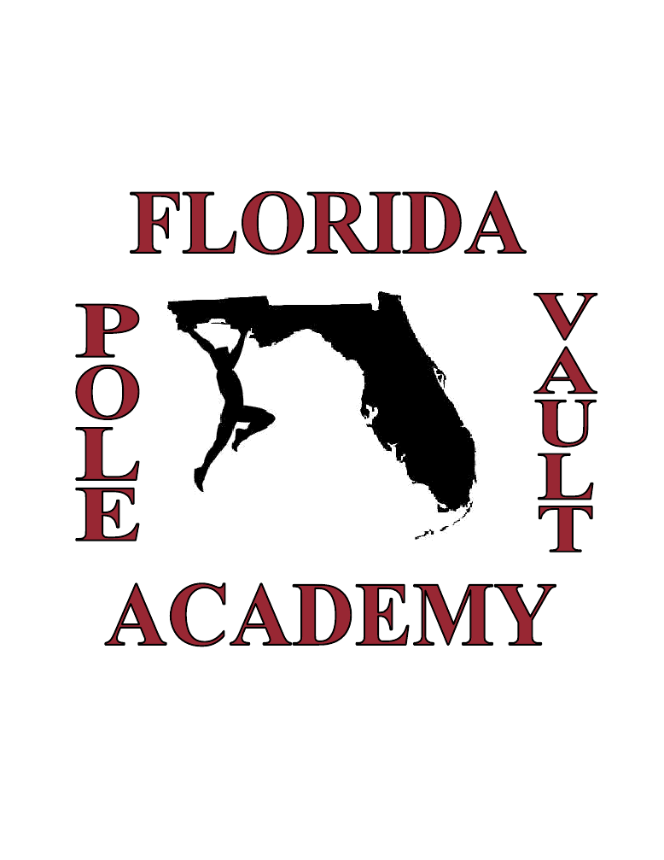
- AAU PV Club
- PV Camps
- Year Round PV Coaching
- Free PV Safety Clinics
- PV Equipment Donations
- All Ages/Levels Welcome
Instructor / FPVA President:

Coach Bob Leidel
(813) 610-5641
Floridapolevaultacademy@gmail.com
www.floridapolevaultacademy.org
Pole Vault Safety Clinics
Free pole vault safety clinics are conducted monthly at our training facility in Wesley Chapel. This is the best place for new vaulters to start, and learn how to manage risks while learning to vault. Check our online schedule or call for dates and times. If you are interested in having the FPVA conduct a safety clinic at your school, please contact us to set a date.


Location

The Florida Pole Vault Academy
Currently Conducts Training at

Wiregrass Ranch High School
2909 Mansfield Boulevard, Wesley Chapel, FL
(location subject to change)

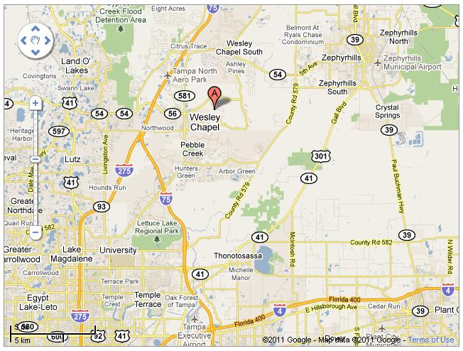
“Of course method is very important as is a high-quality specialist working with you to keep you going in the right direction for your improvement and to help create results.”
-Sergei Bubka – World Record Holder
Read more: http://www.brainyquote.com/quotes/authors/s/sergei_bubka.html#ixzz1LQ0oDA1R

About us
The Florida Pole Vault Academy is a non-profit organization created to provide free coaching of pole vault safety and proper coaching of pole vault technique to un-coached or under-coached youth, and to provide pole vault equipment to schools in need. The FPVA currently conducts free pole vault safety clinics throughout Florida, and provides proper pole vault technique training year around through our Amateur Athletic Union club.
FPVA president, Bob Leidel is a Certified Pole Vault Coach through the National Pole Vault Coaches Association and the Pole Vault Safety Certification Board. He is also a Certified Personal Trainer and Sports Performance Enhancement Specialist through the National Academy of Sports Medicine. Bob currently coaches at Wiregrass Ranch high school in Wesley Chapel, FL near Tampa. Here, he offers pole vault training to all Florida athletes year round.
In addition to offering pole vault training, and free pole vault safety clinics, the FPVA is projecting to donate over $10,000 worth of pole vault equipment to Florida schools in 2011.

Year Round PV Training

The FPVA conducts year round pole vault coaching/ training at Wiregrass Ranch High School in Wesley Chapel, FL. Practices are held 3-5 days per week and are coached by Bob Leidel. Our strategic program is intended to build great fundamental Petrov model vaulters from the ground up. Athletes will learn to master the:

Approach-Run
Plant
Take-off
Drive-swing
Swing-up
Pull-Turn
Bar Clearance

We also develop pole vault specific strength, speed, flexibility, gymnastic ability, and agility. We use many pole vault drills, and mechanisms for training, including; sliding boxes, high ropes, high bars, vault trainers, free weights, bungees, trampolines, swinging bars, e-z plant poles, and many more...

Call or visit our website to see current practice schedule. To participate in this training, all athletes must be AAU Club Members, and purchase a training package listed below.
Instructional Fees Club Membership (one time fee) $50 1 Month Club Practice $100 3 Month Club Practice $270 6 Month Club Practice $500

The FPVA awards up to $6000 in scholarships per year to our program to underprivileged youth athletes. If you may qualify, applications can be found on the FPVA website.
Club/Camp Application and Liability Waiver can be found at www.floridapolevaultacademy.org under the “Join Our Club” heading. Memberships can be purchased, and payments can also be made through the website.

Pole Vault Camps
Pole vault camps are conducted throughout the summer months and include 4 hours of training for 3-5 consecutive days. These camps are a compressed version of our year round strategic training program. Camps are a great way to continue training in the off season if you do not have enough time to participate in a year round program. Pole Vault Camp dates for 2011 are yet to be determined. Price ranges from $150-$250 per camp.
Florida Pole Vault Academy

Bob Leidel, President
Wesley Chapel, FL
Phone: 813.610.5641
www.floridapolevaultacademy.org
floridapolevaultacademy@gmail.com

