Revelation Events Outline – Rev. 13-20

The political kingdoms of the world – Daniel 2 and 7: Babylon, Medo-Persia, Grecia, Roman Empire; and the Religio-political world power of Daniel 7 – the Roman Papacy is a Church and state confederacy (Holy See).

The 'Little Horn' power of Dan. 7 – arose out of the old Roman Empire, persecutes the saints, rules for 1260, etc. - the Roman Papacy. See also 2 Thess. 2

Rev. 13 1-10
The 'Beast out of the Sea' the Papacy and the nations and kingdoms of Europe (the Old World). The Papacy received a 'fatal wound' after the 1260 years of its political supremacy – in 1798 when the French Revolutionary army under Gen. Alexandre Berthier captured Rome, exiled Pope Pius VI and abolished the Papal Government in Rome. This 'wound' was to be later healed in 1929 when the [Vatican State established in 1929].

MUSSOLINI AND GASPARRI SIGN HISTORIC ROMAN PACT
HEAL WOUND OF MANY YEARS
San Francisco Chronicle
Tuesday, February 12, 1929
Cardinal Gasparri
Premier Mussolini
VATICAN AGAIN AT PEACE WITH ITALY AFTER LONG QUARREL
Cardinal leaves sick bed to participate; warmly greets Premier
Chimes of St. John Lateral peal as Signatories Wield Gold Quill Pen
ROME, Feb. 11, - The Roman question was tonight a thing of the past and the Vatican was at peace with Italy. The formal accomplishment of this today was the exchange of signatures in the historic Palace of St. John Lateran by two noteworthy plenipotentiaries, Cardinal Gasparri for Pope Pius XI and Premier Mussolini for King Victor Emmanuel III.
In affixing the autographs to the memorable document healing the wound which has festered since 1870, extreme cordiality was displayed on both sides. The Cardinal Secretary of State warmly welcomed the Premier to the old Papal residence, while Mussolini showed particular attention to the venerable prelate by bidding him sit while the text of the accord was read.
Gasparri Leaves Sick Bed to Sign Document
Cardinal Gasparri left his bed, where he had been confined by grip since Saturday and braved the chilly and sunless weather in order that he might attend the ceremony which was the crowning act of his entire diplomatic career. Premier Mussolini did all he could to soften the rigors of the physical ordeal.

Pope Sees Settlement Between 'Father and Son'
Just as the signatories were wielding the gold quill pen the chimes of St. John Lateran pealed out as if for Christmas midnight and a throng of theological students grouped in the courtyard below broke into the strains of a Te Deum. - We thank thee, Oh God, Make safe thy People, Oh Lord! and bless thy heirs and rule over them and extol them forever."
To this the Fascist Blackshirt militia, personal bodyguard of the Premier, responding with a rousing
-Eja, Eja, Eja Alula!" for the Pope, the Premier and the King. ( . . . . )

Revelation 13:14 (KJV)
And deceiveth them that dwell on the earth by the means of those miracles which he had power to do in the sight of the beast; saying to them that dwell on the earth, that they should make an image to the beast, which had the wound by a sword, and did live.

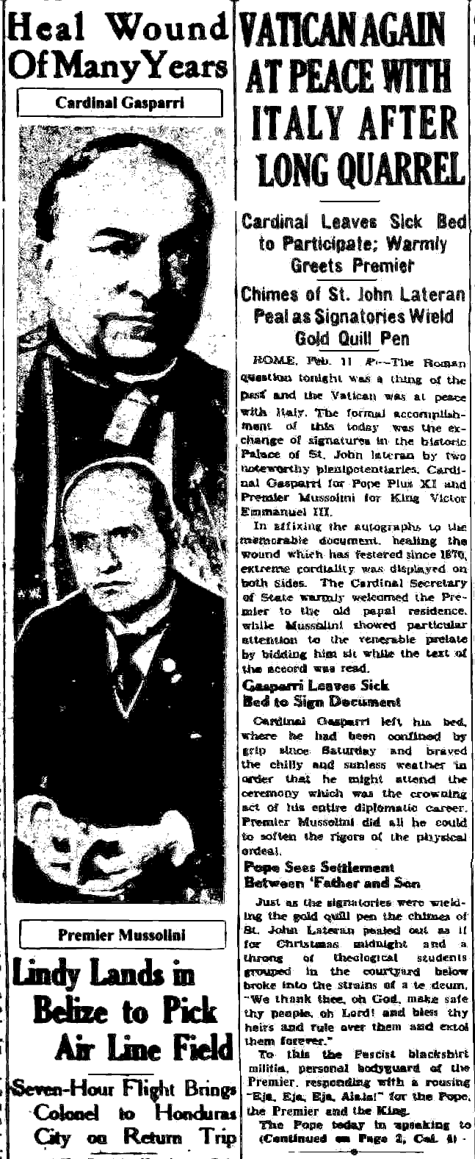

Rev. 13:11-17
THE THREEFOLD UNION – A WORLD UNION OF CHURCH AND STATE
The 'Beast out of the Earth' having horns like a Lamb – The United States arose in the New World as a world power in the latter times of world history. 'Fire down from heaven' The Image to the [first] Beast formed – a future world union of Church and State. The second beast enforces worship of the first Beast who had the wound by the sword (war/conquest) that was healed.
Sunday law or Papal religious observance enforced by a decree of the state – Death decree – Mark of the Beast enforced – 666 the number of the Beast (is not yet fully defined).

Rev. 14
The 3 Angels' Messages – Gospel proclaimed, Babylon the Great is Fallen, Warning against receiving the Mark of the Beast.

The Harvest of the Earth and the Grapes of Wrath – the Sifting and the Shaking of the world.
The World polarized – The Mark of the Beast vs. the Seal of God.

Probation closes?

Rev. 16 – The 7 Last Plagues

Boils and sores on the people having the mark of the Beast – Sea turned to blood – Rivers and waters turned to blood – Sun scorches men – Darkness on the throne and kingdom of the Beast – Euphrates dried up, the kings of the Earth gathered to the battle of Armageddon, the 3 evil toad-like spirits – 7th plague poured out on the air, thunders, earthquake, cities fall, Babylon divided into 3 parts.

Revelation 17-19

The 7 World empires of Revelation 17

Egypt – Assyrian Empire – Babylon – Medo-Persia – Grecia – Roman Empire – Holy Roman Empire – EEC/European Union (the 8th is of the seven).

Judgement against Great Babylon (Papacy and the Roman Catholic Church).
Call out of Babylon – 2nd Angel's message is repeated with greater force.

Rev. 19-20
Christ's second coming – Righteous living and dead raptured up to heaven. Battle of
Armageddon – Wicked slain, Earth desolated, Satan bound for 1000 years, Beast and False Prophet destroyed in the lake of fire.

The Millennium – Saints reign with Christ
Judgement against the Wicked
Satan bound on the desolate Earth.

At the end of the 1000 years:
New Jerusalem descends to the Earth – the Wicked raised up to judgement and damnation – Satan loosed – War of Gog and Magog – destruction of the Wicked and of Satan – Death and Hell cast into the lake of fire.

New Heaven and New Earth formed. Saints remain with Christ and God forever.

