GFWC GREAT LAKES REGION CONFERENCE
TOLEDO, OHIO

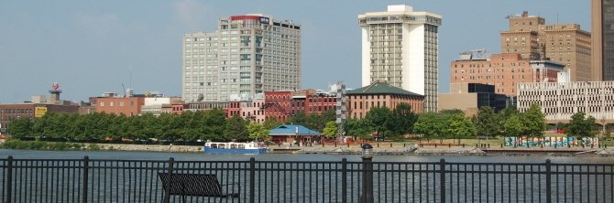

Park Inn by Radisson Toledo, Ohio
101 North Summit Street, Toledo, Ohio 43604
P: 419-241-3000 F: 419-321-2009

1-800-670-7275
Parkinn.com

When calling for a reservation you will need the following information:

NAME: _______________________________
ADDRESS: _____________________________
CITY/STATE/ZIP: ________________________
PHONE:_______________________________
E-MAIL:_______________________________
ARRIVAL DATE:_________________________
DEPARTURE DATE:______________________

All reservations must be guaranteed by a credit card payment for one night’s lodging. The GLR group rate may not be available for requests received after the deadline. Reservations can be canceled up to 24 hours prior to arrival without penalty.

DEADLINE
FOR HOTEL RESERVATIONS
September 8, 2015

ROOM RESERVATIONS REQUEST

Group: GFWC/Great Lakes Region
Group Code: 1510GFWCCN
Date: October 9-11, 2015
Rate: $95.00 per night plus tax

Parking: $10.00 per day NOT included on hotel bill.

Please phone for a reservation; identify yourself as being with the Great Lakes Region Conference with Group Code to get the special rate.

Check-in: 3:00 p.m. Check-out: 12 p.m.
Please reserve Two Double Beds King

1 Person ______________ ______
2 Persons ______________ ______
3 Persons ______________ ______
4 Persons ______________ ______

